Insert measurement page

List view

splash screen

Updating an existing data

After pressing ADD (+) button

After pressing the SUBMIT button the page will navigate to

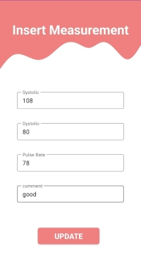

After pressing the EDIT button the user can update existing data

After pressing the UPDATE button the page will navigate to

After pressing the DELETE button the record will be deleted from the page

List view After deleting

List view After Updating